


VIT BHOPAL UNIVERSITY

NAME – Akshitha Sanu
REGESTRATION NUMBER – 26BAC10026
SLOT – B21+E14+E21+B22+E22+C14+B23
EMAIL – akshita.26bac10026@vitbhopal.ac.in
FACULTY/PROFESSOR NAME – Dr. Ajeet Singh

Problem Statement
Python utility for salary calculation of an employee.
Objective
Develop a Python program to calculate the monthly salary of an employee by considering Basic Pay, Dearness Allowance (DA), House Rent Allowance (HRA), other allowances, and deductions such as Provident Fund (PF) and Professional Tax (PT).
Problem Description
The program should accept the employee's Basic Pay and the applicable rates/amounts of different allowances and deductions as input. It should then calculate the employee's Gross Salary and Net Salary.

System Analysis
1. Existing System
In the traditional method, employee salary is calculated manually using a calculator or spreadsheet. The salary components such as Basic Pay, DA, HRA, allowances, PF and Professional Tax are calculated separately. This process can be time-consuming and may lead to calculation errors.

2. Proposed System
The proposed system is a Python-based Salary Calculation Utility that automatically calculates an employee's salary based on the given inputs. It calculates all allowances, deductions, Gross Salary and Net Salary and displays the results in a clear format.

3. Input Requirements
The system requires:
- Basic Pay
- DA percentage
- HRA percentage
- Transport/Other Allowance
- PF percentage
- Professional Tax
4. Processing
The system processes the entered values using predefined salary formulas:
DA = Basic Pay × DA% / 100
HRA = Basic Pay × HRA% / 100
Gross Salary = Basic Pay + DA + HRA + Other Allowances
PF = Basic Pay × PF% / 100
Net Salary = Gross Salary − Total Deductions
5. Output Requirements
The system displays:
- Basic Pay
- DA
- HRA
- Other Allowances
- Gross Salary
- PF
- Professional Tax
- Total Deductions
- Net Salary
6. Feasibility
The system is simple, economical and easy to implement because it requires only Python and a basic computer. It can also be modified easily to include additional allowances or deductions.

WHAT SHOULD BE THE OUTPUT?
The program should calculate:
- Dearness Allowance (DA)
- House Rent Allowance (HRA)
- Transport/Other Allowances
- Gross Salary
- Provident Fund (PF)
- Professional Tax (PT)
- Net Salary

FUNCTIONAL REQUIREMENT
The program should take the following inputs from the user:
- Basic Pay
- DA percentage
- HRA percentage
- Transport/Other Allowance
- PF percentage
- Professional Tax

Formulas Required :
- DA = Basic Pay × DA% / 100
- HRA = Basic Pay × HRA% / 100
- Gross Salary = Basic Pay + DA + HRA + Other Allowances
- PF = Basic Pay × PF% / 100
- Net Salary = Gross Salary − (PF + Professional Tax)

EXPECTED OUTPUT
The program should display:
- Basic Pay
- DA amount
- HRA amount
- Other Allowances
- Gross Salary
- PF deduction
- Professional Tax deduction
- Net Salary payable to the employee
Sample
If:
- Basic Pay = ₹50,000
- DA = 50%
- HRA = 20%
- Transport Allowance = ₹3,200
- PF = 12%
- Professional Tax = ₹200
The program should calculate and display the Gross Salary and Net Salary along with all individual components.
The output in this case will be:
• DA = 50,000 × 50% = ₹25,000
• HRA = 50,000 × 20% = ₹10,000
• Gross Salary = 50,000 + 25,000 + 10,000 + 3,200 = ₹88,200
• PF = 50,000 × 12% = ₹6,000
• Net Salary = 88,200 − (6,000 + 200) = ₹82,000

Non-Functional Requirements
The Python salary calculation utility should meet the following non-functional requirements:
- Accuracy – The program should perform salary calculations accurately without mathematical errors.
- Usability – The program should be simple and easy to use, with clear instructions for entering employee details.
- Performance – The program should calculate and display the salary details quickly.
- Reliability – The program should provide consistent and correct results for valid inputs.
- Readability – The output should be clearly formatted so that all salary components and deductions are easy to understand.
- Maintainability – The Python code should be well-structured and easy to modify if new allowances or deductions are added.
- Error Handling – The program should handle invalid inputs, such as negative salary values or non-numeric entries, appropriately.
- Portability – The program should run on standard systems that have Python installed without requiring specialized hardware or software.

How to run your program
Step 1: Install Python
- Download and install Python from the official Python website.
- During installation, select “Add Python to PATH.”
Step 2: Write the Program
- Open IDLE, VS Code, or any Python editor.
- Type or paste your salary calculation program.
- Save the file as:
salary_calculator.py
Step 3: Run the Program
In IDLE:
- Open salary_calculator.py
- Click Run → Run Module
- Or press F5
In VS Code:
- Open the file.
- Click the Run ▶ button.
Using Command Prompt:
- Open Command Prompt.
- Go to the folder where the file is saved.
- Type:
python salary_calculator.py
- Press Enter.
Example
The program will ask for inputs such as:
Enter Basic Pay: 50000
Enter DA Percentage: 50
Enter HRA Percentage: 20
Enter Transport Allowance: 3200
Enter PF Percentage: 12
Enter Professional Tax: 200
It will then display:
Gross Salary: ₹88,200.00
Net Salary: ₹82,000.00
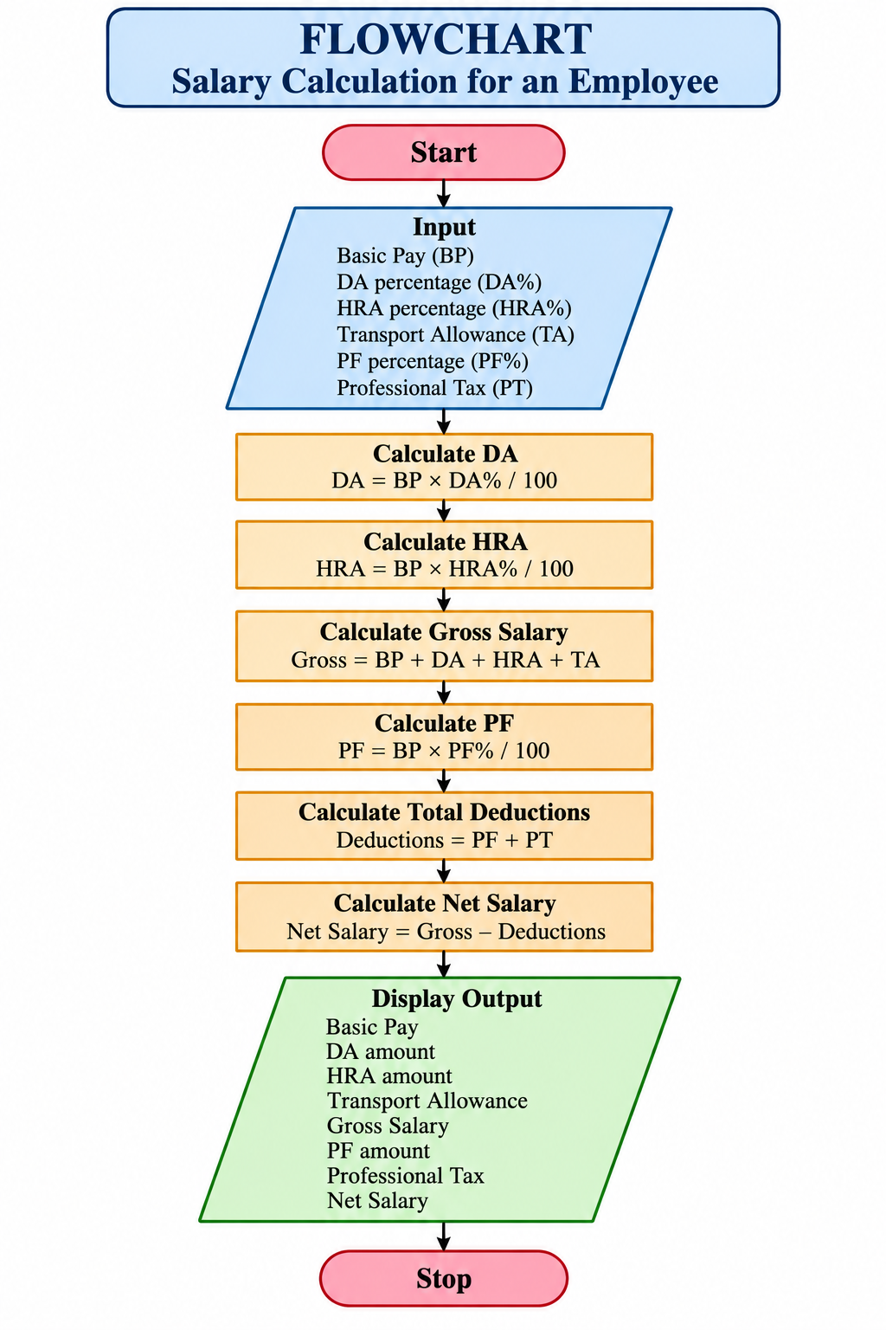
Pseudocode – Employee Salary Calculation
BEGIN

DISPLAY "Employee Salary Calculation"

INPUT Basic_Pay
INPUT DA_Percentage
INPUT HRA_Percentage
INPUT Transport_Allowance
INPUT PF_Percentage
INPUT Professional_Tax

DA = (Basic_Pay × DA_Percentage) / 100

HRA = (Basic_Pay × HRA_Percentage) / 100

Gross_Salary = Basic_Pay + DA + HRA + Transport_Allowance

PF = (Basic_Pay × PF_Percentage) / 100

Total_Deductions = PF + Professional_Tax

Net_Salary = Gross_Salary - Total_Deductions

DISPLAY "Basic Pay:", Basic_Pay
DISPLAY "Dearness Allowance:", DA
DISPLAY "House Rent Allowance:", HRA
DISPLAY "Transport Allowance:", Transport_Allowance
DISPLAY "Gross Salary:", Gross_Salary
DISPLAY "Provident Fund:", PF
DISPLAY "Professional Tax:", Professional_Tax
DISPLAY "Total Deductions:", Total_Deductions
DISPLAY "Net Salary:", Net_Salary

END
VARIABLE TABLE
 | Float  Float  Float  Float  Float  Float  Float  Float  Float  Float  Float  Float | Description  Basic salary of the employee.  Percentage of Dearness Allowance.  Percentage of House Rent Allowance.  Fixed transport allowance.  Percentage of Provident Fund deduction.  Professional Tax deduction.  Calculated Dearness Allowance.  Calculated House Rent Allowance.  Total salary before deductions.  Calculated Provident Fund deduction.  Total amount deducted from salary.  Final salary after deductions.
  Variable
  Basic_Pay
  DA_Percentage
  HRA_Percentage
  Transport_Allowance
  PF_Percentage
  Professional_Tax
  DA
  HRA
  Gross_Salary
  PF
  Total_Deductions
  Net_Salary
  Data Type

PYTHON CODE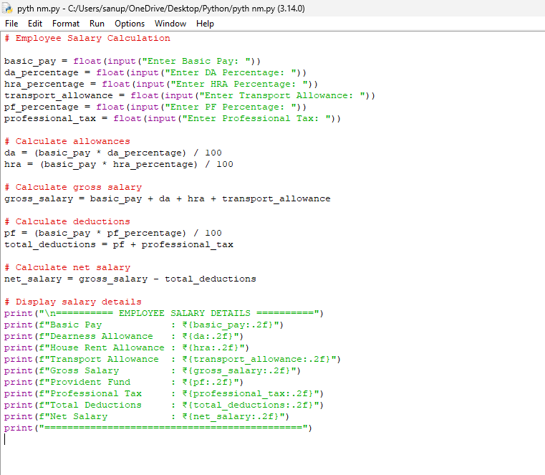

SAMPLE INPUT
Basic Pay = ₹50,000
DA Percentage = 50%
HRA Percentage = 20%
Transport Allowance = ₹3,200
PF Percentage = 12%
Professional Tax = ₹200
SAMPLE OUTPUT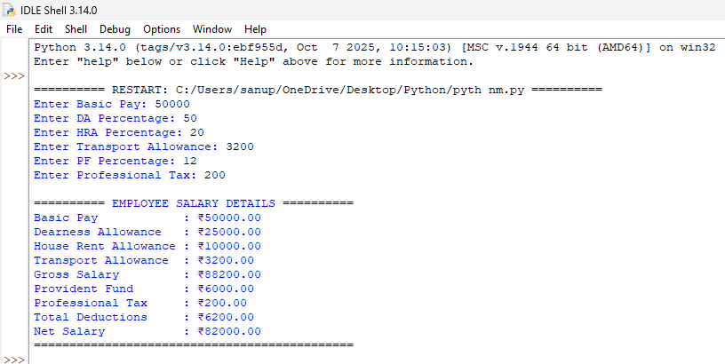
Limitations
- The program calculates the salary for one employee at a time.
- It does not store employee details permanently in a database.
- Salary rates such as DA and HRA must be entered manually by the user.
- It does not calculate Income Tax or other statutory deductions.
- It does not include bonuses, overtime, loans, arrears or other special payments.
- The basic version requires the user to enter valid numerical values.
- It does not generate an automatic salary slip or PDF report.
- It is a basic console-based application and does not have a graphical user interface (GUI).

Conclusion
The Employee Salary Calculation Utility successfully calculates an employee’s salary using Basic Pay, DA, HRA, allowances, and deductions. The Python program reduces manual calculation errors and provides the Gross Salary, Total Deductions, and Net Salary in a clear and systematic manner. It is simple, accurate, user-friendly, and can be further modified to include additional salary components.

Bibliography
- Python Software Foundation. Python 3 Documentation.
- Downey, Allen B. Think Python: How to Think Like a Computer Scientist. O’Reilly Media.
- Sweigart, Al. Automate the Boring Stuff with Python. No Starch Press.
- W3Schools. Python Programming Tutorials and Reference.
- GeeksforGeeks. Python Programming and Computer Science Resources.
- Course notes and study materials provided by the college.

